- \Operation\Basic settings\Central lubrication
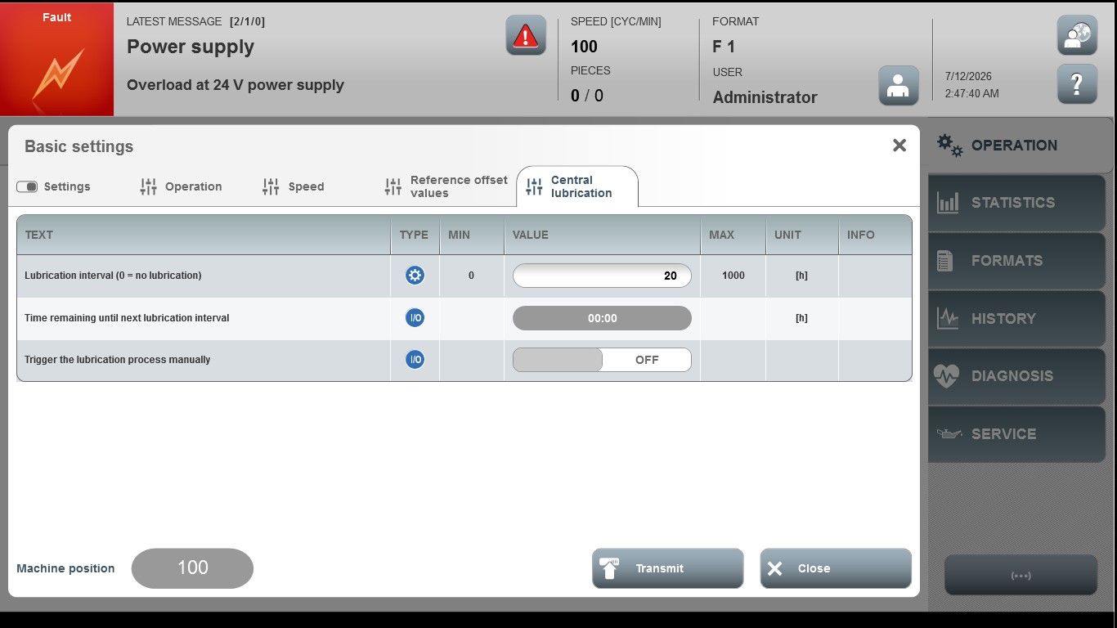
Acceptance criterion | Limits | Pass / Fail: Dev-No. | Date | Initials
Screen matches screenshot | N / A
Lubrication interval (0=no lubrication | 0 ... 1000

